INTERNSHIP TASKS

Name : S. Deva Manikanta

Clg Id : 12119003

Course : Python

Org : IGIAT – VSKP

Date : 12-04-2024

Day 10: EXERCISE – 10

Exercise Level 1

#Task 1

#Iterate 0 to 10 using for loop, do the same using while loop

#For Loop

print("Using For Loop : ", end = " ")*;*

for i in range(0, 11):

    if(i == 10):

        print(i)*;*

    else:

        print(i, end=",")*;*

#While Loop

i = 0*;*

print("Using While Loop : ", end = " ")*;*

while(i <= 10):

    if(i == 10):

        print(i)*;*

    else:

        print(i, end=",")*;*

    i += 1*;*

#Task 2:

#Iterate 10 to 0 using for loop and while loop

print("Using for loop : ", end="")*;*

for i in range(10 , -1, -1):

    if(i == 0):

        print(i)*;*

    else:

        print(i, end = ",")*;*

i = 10*;*

print("Using while loop : ", end="")*;*

while(i >= 0):

    if(i == 0):

        print(i)*;*

    else:

        print(i, end = ",")*;*

    i -=  1*;*

#Task 3: Write a loop that makes seven calls to print(), so we get traingle pattern:

i = 1

while(i <= 7):

    for j in range(1, i+1):

        print("#", end = "")*;*

    print()*;*

    i += 1*;*

#Task 4:

# Use nested loops to create the following

for i in range(1, 9):

    for j in range(1, 9):

        print("# ", end = "")*;*

    print()*;*

#Task 5:

#Print the following pattern

for b in range(0, 11):

    print(b,"x", b, "=", (b*b))*;*

#Task 6:

#Iterate through the list ['Python', 'Numpy', 'Pandas', 'Django', 'Flask'] using for loop and print out the items:

for i in ['Python', 'Numpy', 'Pandas', 'Django', 'Flask']:

    print(i)*;*

#Task 7:

#Use for loop to iterate from 0 to 100 and print only even numbers

print("Even Numbers from 0 to 100:")*;*

for i in range(0, 101):

    if(i % 2 == 0):

        if(i == 100):

            print(i)*;*

        else:

            print(i, end=",")*;*

    else:

        continue*;*

#Task 8:

#Use for loop to iterate from 0 to 100 and print only odd numbers

print("Odd Numbers from 0 to 100:")*;*

for i in range(0, 101):

    if(i % 2 != 0):

        if(i == 99):

            print(i)*;*

        else:

            print(i, end=",")*;*

    else:

        continue*;*

**Outputs:**

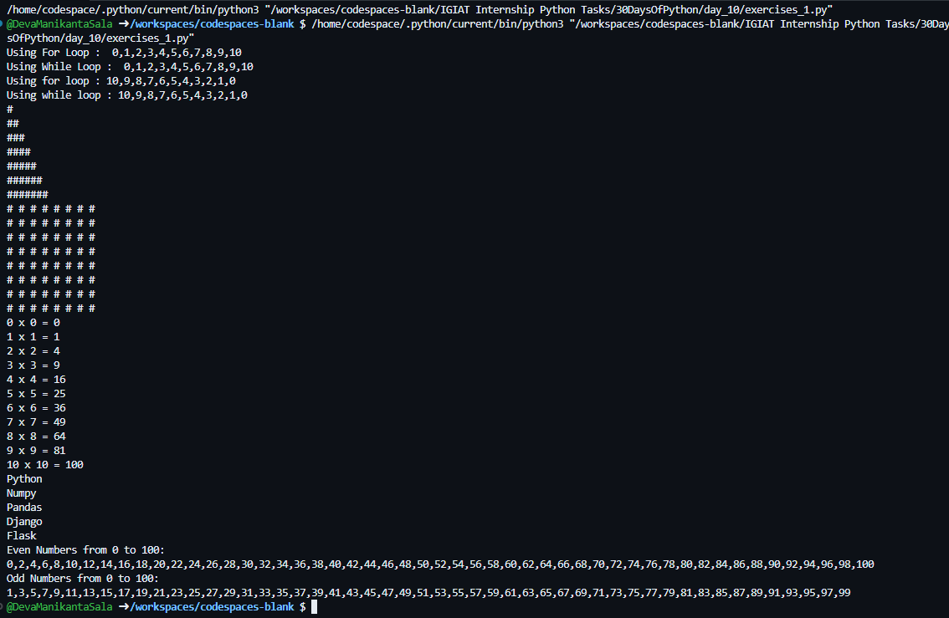

Exercise Level 2

#Task 1

#Use for loop to iterate from 0 to 100 and print the sum of all numbers

sum = 0

for i in range(0, 101):

    sum += i*;*

print("The Sum of all numbers from 0 to 100: ", sum)*;*

#Task 2

#Use for loop to iterate from 0 to 100 and print the sum of all evens and odds seperately

sum_of_even = 0

sum_of_odd = 0

for i in range(0, 101):

    if(i % 2 == 0):

        sum_of_even += i*;*

    else:

        sum_of_odd += i*;*

print("Sum of Even numbers from 0 to 100: ", sum_of_even, "\nSum of Odd numbers from 0 to 100: ", sum_of_odd)*;*

**Output:**

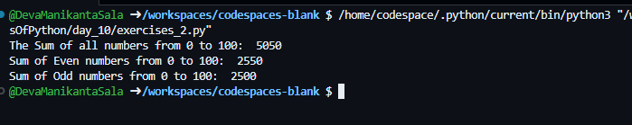

Exercise Level 3

Step 1: Create a folder ‘data’ and download ‘countries.py’ click on [this](https://drive.google.com/uc?export=download&id=19FKmSln0zclQ97yUkFponmuWvyO4OGe9) link to download the file and paste it in ‘data’ folder.

*Try this link if it doesn’t download:*

[*https://drive.google.com/uc?export=download&id=19FKmSln0zclQ97yUkFponmuWvyO4OGe9*](https://drive.google.com/uc?export=download&id=19FKmSln0zclQ97yUkFponmuWvyO4OGe9)

Step 2: Now, download this file and paste it in ‘data’ folder ‘countries_data.py’ click on [this](https://drive.google.com/uc?export=download&id=1aumrIQiumLBau9hTUPNEQBYgxZp-MwAo) link to download the file.

*Try this link if it doesn’t download:*

[*https://drive.google.com/uc?export=download&id=1aumrIQiumLBau9hTUPNEQBYgxZp-MwAo*](https://drive.google.com/uc?export=download&id=1aumrIQiumLBau9hTUPNEQBYgxZp-MwAo)

#Task 1

#Go to the data folder and use the countries.py file. Loop through the countries and extract all the countries containing the word 'land'.

from data import countries as c;

countries_ends_with_land = []

for country in c.countries:

    if(country.endswith("land")):

        countries_ends_with_land.append(country)*;*

print("Countries ends with land : ", countries_ends_with_land)*;*

#Task 2

#This is a fruit list, ['banana', 'orange', 'mango', 'lemon'] reverse the order using loop

fruits = ['banana', 'orange', 'mango', 'lemon']

reversed_fruits = []

for i in range(-1, -(len(fruits)+1), -1):

    reversed_fruits.append(fruits[i])*;*

fruits = reversed_fruits*;*

print("Reversed : ", fruits)*;*

#Task 3

#Go to data folder and use the countries_data.py file

from data import countries_data as cd;

#1. What are the total number of languages in the data

languages = 0*;*

for item in cd.countries_data:

    languages += len(item['languages'])

print("The Total number of languages : ", languages)*;*

#2. Find the ten most spoken languages from the data

languages_spoken = []

for item in cd.countries_data:

    for language in item['languages']:

        languages_spoken.append(language)*;*

unique_languages = set(languages_spoken)*;*

counts_of_unique_languages = {}

for language in unique_languages:

    counts_of_unique_languages[language] = languages_spoken.count(language)*;*

counts = list(counts_of_unique_languages.values())*;*

counts.sort()*;*

counts.reverse()*;*

counts = counts[0:10]*;*

i = 0*;*

ten_most_spoken_languages = []

while(i < len(counts)):

    for language, count in counts_of_unique_languages.items():

        if(count == counts[i]):

            ten_most_spoken_languages.append(language)*;*

    i += 1*;*

print("Ten Most spoken languages : ", ten_most_spoken_languages)*;*

#3. Find the ten most populated countries in the world

population_of_countries = []

for item in cd.countries_data:

    population_of_countries.append(item['population'])

population_of_countries.sort()*;*

population_of_countries.reverse()*;*

population_of_countries = population_of_countries[0:10]*;*

i = 0*;*

ten_most_populated_countries = []*;*

while(i < len(population_of_countries)):

    for item in cd.countries_data:

        if(item['population'] == population_of_countries[i]):

            ten_most_populated_countries.append(item['name'])*;*

    i += 1*;*

print("Ten Most Populated Countries: ", ten_most_populated_countries)*;*

**Output:**

